DEVELOPMENT OF DORMANCY IN SEEDS OF SAPIUM SEBIFERUM (L.) ROXB DURING MATURATION
Jing Hou, Hailin Liu, Qiuyue Ma, Wenting Wei, Tongming Yin and Shuxian Li

The Southern Modern Forestry Collaborative Innovation Center, Nanjing Forestry University, Nanjing 210037, China

Running title: Development of seed dormancy in Sapium sebiferum

Jing Hou Fax : 01186-25-85427402, Email: zhucai4425@126.com, address: 159# Longpan Road, Nanjing Forestry University, Nanjing, 210037, China
Hailin Liu Fax : 01186-25-85427402, Email: lhl21@foxmail.com, address: 159# Longpan Road, Nanjing Forestry University, Nanjing, 210037, China
Qiuyue Ma Fax : 01186-25-85427402, Email: yue.870808@163.com, address: 159# Longpan Road, Nanjing Forestry University, Nanjing, 210037, China
Wenting Wei, Fax : 01186-25-85427402, Email: 308499336@qq.com, address: 159# Longpan Road, Nanjing Forestry University, Nanjing, 210037, China
Tongming Yin Fax : 01186-25-85427402, Email: tmyin@njfu.com.cn, address: 159# Longpan Road, Nanjing Forestry University, Nanjing, 210037, China

Dr. Shuxian Li
The Southern Modern Forestry Collaborative Innovation Center,
159# Longpan Road, Nanjing Forestry University, Nanjing, 210037, China
Email: shuxianli@njfu.com.cn
Phone: 01186-25-85427403
Fax: 01186-25-85427402
Abstract
Sapium sebiferum seeds were harvested from the same plant at five developmental stages of maturity to study the changes in fresh weight, dry weight, moisture content, germination percentage, endogenous inhibitor activity and plant growth regulators (PGRs) content. Moisture content of seeds declined from 46.98% (collected on 1 1 Septber, abo2.00% (seeds ted on 1 November). Fresh weight decreased while dry weight increased significantly during seed development. Germination inhibitor activity in the seed coat and endosperm increased during seed maturation and, at the sam developmental stage, inhibitor activity in the seed coat was higher than that in the endosperm. E Excised embos were capable of germinating for seeds collected from on 16 mber, nd maximum percentage gpercentage was observed for seeds collected on 16 October. With increasing seed maturation, gibberellins (GAs) content decreased while abscisic acid (ABA) content increased in both the stratified and unstratified seeds whereas absc the unstratified controls, the stratified seeds were consistently found to have lower ABA content and higher GAs content throughout differentthe controls. At all develstagontent of trtment wasss he sta those of the tifiedcas found to steadily decreased in both the stratified and unstratified seedsin control andstratified seeds, with an exceptional observatllected on 1 October that underwent stratificationan initial in on 1 October in stratified seeds. With inceasing seed matds initially increased but declined after 1 October. Stratified seeds showede trend, but with higherthe , at each developmental stage, germination percentage germination of stratified s was higheravelopmental stages. RThe results y showed thaare wture and incapable of germinating, whereas seeose harvested in November are were fully mature but showed stronrmancy. This study showed that seeds are ready to haon 1 October, and they will rally dispersed in November. Thus we proposed that it is better to harvest seeds before the middle of 1- 16 Harvesting seeds in October is was the desirable time to harvestseeds collect seeds for rapid and efficient germination.

Key words: endogenous inhibitor, excised embryo, GAs, ABA

INTRODUCTION
Seed maturation is an important phase of seed development during which embryo growth ceases, food reserve accumulates, the protective tegument differentiates and tolerance to desiccation develops, leading to seed dormancy (Gutierrez1 et al. 2007). In this procedure theuch factors as ine previous researchesstudies showed dormancy obe due to endogenous inhiitors in the soveringtissues surrounding the embryo (Bhattacharyya et al. 199. phenolics were identified as Some of ts of inhibitors in seedsAcer seedsof some ree species in genus of Acer (Phartyal et al2003)(are phenolics (Enu-Kwesi adff 1978), while in A.(Petrova anikolaeva, 1974) and A.charunu-Kesi and Dumbroff, 1978) )the main nhibitor has been identified sd (ABA). Besis,So it is a complex, regulated metabolic events and the involvement of such factors as plant growth regulators (PGRs) and elicitors.
hGAs) also play an play an important regulatory role in regulating the dormancy and germination of trova andNa 1974,roy 1998,, John play an important regulatory role in the dormancy and germination of seeds (Ritchie and Gilroy 1998, John et al. 2002). Among PGRsThe previous researches showed that abscisic acid (, ABA) implicated in the dormancy of mature seeds of many species (Pinfield and Gwarazimba 1992) and also there is a direct correlations between deep dormancy and high ABA levels (Singh and Browning 1991) plays a pivotal role during the development of dormancy (Koornneef et al. 2002, Kucera et al. 2005),. and For example, in apple embryos increasing levels of ABA were closely correlated with the gradual establishment of dormancy 9(Bouyon and Bulard 1986). Gibberellins (GAs) are involved in the induction of germination (Brady and McCourt 2003, Bai et al. 2011). ABA and GAs have antagonistic effects on seed dormancy and germination. The GAs:ABA ratio is an important factor that affects seed germination and a high ratio leads to improved germination (El-Araby et al. 2006, Sudhakar et al. 2011). Determination of the timing of seed maturity is essential for optimal, economic harvesting of healthy, viable and germinable seeds (Phartyal and Thapliyal 2006).
fa, isred in landscies, wanion of biodiesel, d-mspecies.
S. sebiferum is commonly propagated from seeds, but itsopagation isseriously impeded by seed dormancy.dormespeciay coeds would, resuling in r germination (Li et al. 2012). Previous studiened dormancy in S. sebiferum is was nly caused by the seendnous inhibitors presented in the endosperm and seedi et al. 2011). However, quantitative assessment of the development uring seed maturation has not previously been investhe previous studies. Therefore, we conducted thikstudy to gain a better understgontents of endogenous inhibitor and PGRs contents during seed maturation of S. sebifer

con

Materials and methods
Plant material
S. sebiferum usually starts to flower in early July, and seeds mature in late October with natural dispersal inand Nover in Nanjxpers in this study were performed with seeds collected from a single tallow tree, within dier of 25cm, atin Xuanwu LakPark in Nanjing, China.carried out durllected from a single tnth from the 1st of 14- to 15-day intervals 1sis) until the natural dispersal of seedsal.After collection, the capse wall was carefully removed to release the seeds. The fresh weight, dry weight and moisture content were measured in for seeds with the white waaril intact. All seeds used for otlyses were washed in 1% NaOH for 1 h to remove the white waxy ariltallow. Subsequently, the seed rinsed with tap water, cleaned with paper and dried at room temperature for 1 day, and then stored in sealed pla in a refrigerator at 0–5°C until use. Meanwhile, we selected portion

Seed fresh and dry weights
Four replicates, each containing 50 seeds with the white waxy aril, were weighed (to 0.001 g accuracy) to obtain the fresh weight for each harvest. The dry weight was determined after drying at 80°C to a constant weight and cooling in a desiccator containing silica gel (Pinfield and Gwarazimba 1992).

Seed moisture content
The moisture content of seeds was determined by means of a constant-temperature oven method according to the International Seed Testing Association Rules (ISTA 2011). Three replicates, each with 20 seeds, were dried in a drying oven at 103°C for 17 h, then cooled in a desiccator with silica gel, and reweighed for estimation of the moisture content on a fresh weight basis.

Germination test with excised embryos
Seeds at the different developmental stages were soaked for 2 d in running water. After excision from their enclosing seed, the embryos were placed in plastic boxes containing wet absorbent cotton and incubated at 25°C with an 8 h photoperiod. During the incubation, the embryos were watered every 2 d to maintain the moisture level. Germination was recorded every 2 d for a total of 16 d. The germination percentage of the excised embryos was calculated at the end of the experimental period. Germination tests were done with four replicates, with each containing 50 seeds. Unless stated otherwise, all the following experiments in this study were performed with the same numbers of seeds in the same replicates.

Effect of extracts from the seed coat and endosperm on germination of cabbage seeds
Inhibitors were extracted from the coats and endosperms of S. sebiferum seeds with organic solvent. The activity of each extract was determined by the germination percentage of the non-dormant seeds of cabbage (Brassica rapa L. Chinese Group) on filter paper moistened with the extracts. The method was according to Phartyal et al. (2003) with some modification. First,
seed coats and endosperms were separately excised from seeds harvested on 16 September, 16 October and 1 November. Then they were separately grounded into powder in liquid nitrogen, and the powder was extracted with methanol in Soxhlet apparatus. Samples (5 g) of each tissue were extracted three times for 24 h, each with 100 ml of 80% (v/v) aqueous methanol at 5°C. After filtration, supernatants from three extractions for each tissue were combined and evaporated under vacuum at 37°C to remove the methanol. The final volume was made up to 50 ml by distilled water.
Germination of cabbage seeds was estimated with three replicates, with each containing 100 seeds. Seeds in each replicate were soaked in 5 ml of the extract solution for 3 h. Seeds of controls were soaked in distilled water. Seeds germination was carried out in a seed germination chamber wth temperature maintained at 25°C wit an 8 h light photoperiod. Seedling emergence was counted daily after incubation of 6 d. Seedlings were recorded as emerged when the cotyledons were visible in accordance with ISTA rules (ISTA 2011).

lGRs)Endogenous hormone conte
The contents of GAs, ABA and the ratio of GAs:ABA were measured for the freshly harvested seeds (untreated) and seeds that were treated with cold stratification (at 0–5°C) for 30 d. The hormone contents were determined using an indirect enzyme-linked immunosorbent assay (ELISA) technique (Bai et al. 2011, Yuan et al. 2009) with some modifications. In detail, 500 mg of seeds were ground into powder in liquid nitrogen and extracted in cold 80% (v/v) methanol containing 1 mM butylated hydroxytoluene as an antioxidant. The extracts were incubated at 4°C for 4 h under agitation. The samples were centrifuged using a Allegra 25R centrifuge (Beckman Coulter, Inc.) at 3500 r/min for 8 min at 4°C and the supernatant was recovered through Chromosep C₁₈ columns (C₁₈ Sep-Pak Cartridge, Waters Corp., Millford, MA, USA), then prewashed with 1 ml of 80% (v/v) methanol. The PGRs fractions from the columns were eluted with 5 ml of 100% (v/v) methanol and 5 ml ether. The supernatant was air-dried to remove residual methanol. The dried supernatant was dissolved in 2 ml phosphate-buffered saline (PBS) containing 0.1% (v/v) Tween-20 and 0.1% (w/v) gelatin for the ELISA assay.
The concentrations of GAs and ABA were determined using a competitive ELISA method. ELISA was performed using a 96-well ELISA plate. Each well was filled with 50 μl of extract. All samples were run in three replicates, and GAs or ABA standards were included in each run for construction of a standard curve. Standard and sample absorbency was recorded at 490 nm using a microplate reader, and GAs or ABA content was measured by interpolation from the standard curve of Weiler et al. (1981).

Germination test at standard conditions
Seeds of S. sebiferum from each harvest were immersed in Milli-pore filtered water for 24 h at room temperature on the same day. After soaking, the seeds were placed in plastic boxes with moistened sand and stored in a refrigerator at 0–5°C for 30 d. Seeds soaked in water for 24 h with no cold stratification were used as the control. After that, seeds were incubated at 25°C. Germinated seeds were counted every the other day. Two months later, the final germination percentage was calculated as the proportion of normal seedlings relative to the total number of seeds sown as recommended by ISTA (2011).

Statistical analysis
Data from the different experiments were analyzed separately. The significance of treatments was tested by one-way analysis of variance, and Duncan’s multiple range test was used to identify significant differences between means.

RESULTS
Fresh weight, dry weight and moisture content of the seed
The fresh weight, dry weight and moisture content of seeds with the tallow aril on each harvest date were listed in Table 1. The seeds showed a significant decrease in fresh weight from 5.240 g to 4.128 g (p < 0.05) from 1 September to 1 November, and a significant increase in dry weight from 1 September to 16 October (p < 0.05), with only a small increase in dry weight observed on 1 November. The moisture content of seeds decreased throughout the maturation period. By the time the seeds attained full maturity, the moisture content had declined from a maximum of 46.98% 12.00% on the basis of fresh weightFW

Germination of excised embryos
Differences in the germination capability of excised embryos from seeds collected on different dates were listed in table 2. Embryos excised from seeds collected on 1 September were immature, so they failed to germinate. The germination percentage of excised embryos from seeds collected on 16 September was still low (42.5%) and most embryos were incapable of developing into normal seedlings. From seeds collected on 1 October, when the fruit was still green, about 90% of the excised embryos were capable of germinating. The percentage germination of embryos excised from seeds collected on subsequent dates showed no significant difference from those collected on 1 October.

Germination of seeds with increasing maturity and cold stratification treatment
S. sebiferum seeds soaked in water for 24 h, then treated with 0 (control) or 30 d cold stratification, following incubation at 25°C for two months. The germination percentage of seeds in these two treatments was shown in Fig. 1. In general, with increasing seed maturity, the germination percentage of the control increased at the beginning, and it was up to 66.3% for seeds harvested on 1 October. Then germination percentage declined, and it was only 18.5% for seeds harvested on 1 November (seeds naturally dispersed). This revealed that the good germination ability present at earlier developmental stages was gradually lost as the propagules approached maturity, which was caused by increasing seeds dormancy in mature seeds. With increasing seed maturity, the percentage of fresh seeds (rble to imbibe water when provided with the conditions set out, but the germination process is blocked) (ISTA 2011) increased from 10.5% to 75.3%, which. Tho indicated that the seeds harvested on 1 November possessed strong dormancy.
Germination percentage of the stratified seeds showed similar trends as that of the control. However, for seeds harvested on the same date, germination of the stratified seeds was higher than that of the control, e.g., for seeds collected on 16 September, the germination percentage was 28.7% in the control, while it was 39.5% in the stratification treatment. Seeds collected on 1 September were incapable of germinating in both the control and stratification treatment. This result was consistent with that of the germination test with the excised embryos described above. The percentage of viable seeds (germinated and fresh seeds) on 16 September was about 40%, which was much lower than that of seeds collected on subsequent dates. imposed dormancy. SoIn order to compare the inhibitory effect of the seed envelops, we was evl the ratio: ((%germinated embryos% - %germinated seeds%) / % germinated embryos%) ×x 10he minimum rat on 1 October (25.5%), and ten increasesd up to 53.% and 80.2% October 16nd November 1on 16 Octbe nd 1 Novemberthe subsequent harvest times, respectively (Table 43).

Effect of seed coat and endosperm extracts on germination of cabbage seeds
Extracts from the seed coat and endosperm of S. sebiferum can significantly reduce the germination percentage of cabbage seeds (p=0.05; Table 4). For seeds collected on different dates, the seed coat extract had a stronger inhibitory effect than the endosperm extract, and the inhibitory effect intensified with increasing seed maturity. For example, the seed coat extract from seeds harvested on 1 November severely reduced the germination of cabbage seeds from 78.3% (treated with seed coat extract from seeds collected on 16 September) to 25.7%. Thus, naturally dispersed seeds were supposed to contain a highestntent of theibitors.

PGRs content in seeds
The levels of GAs and ABA tested by ELISA in the seeds with increasing maturity and cold stratification treatment were shown in Fig.2 and Fig.3. No significant difference was found in GAs content for Teeds harvested on 16 September and 1 October in the control sFig. 2). However, on the subsequent harvest dates, the GAs content decreased from 17.86 ng g⁻¹ (on 1 October) to 9.56 ng g⁻¹ (on 1 November) in the control. Compared with the control, the stratified seeds always had aTcold stratifa cation for th had aied seeds was alopmental stages (Fig.2)..
For both stratified and the control seeds seeds ABA levels at the earlyiest ss invests 1 October) were comparatively low. An appreciable increase in seeds ABA content was observed from 1 October to 16 October, and thereafter t smaller increase was on 1 November. At all four stages tThatified seeds was much lower than that in the control throughout the experimental period dis (Fig. 3).
With increasing seed maturity, the GAs:ABA ratio of seeds in the control showed a steady decrease from 0.18 to 0.04. For the stratified seeds, this ratio also declined except for that of seeds harvested on 1 October. The ratio varied more significantly from 0.31 to 0.13) for the stratified seeds than the control (Fig. 4), and the lowest GAs:ABA ratio was observed in seeds harvest on 1 November for both the cold stratification treatment and the control.

DISCUSSION
Changes in inhibitor activity during seed maturation
Previous studies have revealed that chemical inhibitors play a major role in suppressing seed germination (Phartyal et al. 2003). In the present study, we observed that at the same developmental stage, the activity of inhibitors in the seed coat was higher than that in the endosperm, as indicated by their inhibitory effects on cabbage seed germination. However, in an individual seed, these results did not necessarily mean the activity of inhibitors in the seed coat was higher than that in the endosperm, because different quantities of seeds were needed to obtain the two extracts. In this experiment twenty seeds were used in obtaining extracts from the seed coat and 10 seeds used for the endosperm extracts. On the other hand, with increasing seed maturity, the germination percentage of cabbage seeds decreased significantly. Given that the decrease in cabbage seed germination reflected inhibitor activity, it can be concluded that inhibitor activity increased with seed maturation. This may be correlated with strong dormancy of mature seeds of S. sebiferum. However, this result differed from those of Zhang (2008) for Fraxinus mandshurica Rupr. He found that the intensity of seed dormancy did not reflect inhibitor activity. The different conclusions in the two experiments indicate that the factors contributing to seed dormancy differ among plant taxa. The present study only determined inhibitor activity in the seed coat and endosperm. Further investigations are required to elucidate the role of germination inhibitors in seed dormancy and the identity of the inhibitors in S. sebiferum seeds.

Changes in GAs and ABA content during seed maturation
The previous studies indicated that dormancy and germination are controlled by the action and interplay of the hormones(White et al. 2000). Among these hormones, ABA is a positive regulator of dormancy induction and a negative regulator of germination (Kucera et al. 2005), while GAs are involved in the induction of germination (Brady and McCourt 2003, Bai et al. 2011). In this study, we determined the contents of ABA and GAs to gain a better understanding of hormonal changes associated with dormancy. The present study showed that free ABA levels of the control seeds were low during seed development, but reached maximum levels at seed maturity. On the same harvest date, the ABA content of stratified seeds was lower than that of control seeds (Fig. 3), which was in accordance with the higher germination percentage of stratified seeds compared with the control (Fig. 1).
The GAs content of the control seeds showed the opposite trend to that of ABA. This trend may reflect a decline in the synthesis and deposition of seed reserves, and the general retardation of metabolism due to seed desiccation (Bewley and Black 1978). After seeds were treated by cold stratification, the GAs content was markedly higher than that of the control seeds, which is presumed to reflect the breaking of dormancy by stratification.
Mature seeds contained a lower GAs:ABA ratio than immature seeds. GAs:ABA ratio was found to be negatively correlated with the intensity of seed dormancy. These results are in agreement with those of Amen (1968).
In summary, seed coat and endosperm extracts and free ABA were correlated with the observed germination soppressed the germination of ay suppre the of S. sebifeeds. , even at the earlie developmental stages investigated; For xed (TableFig. 31),reas 89.03% of embryos excised from seeds collectedhe se date were capale of germinating (Table 2). However, whether the embryos excised from dormant seeds are more sensitive to free ABA remains unresolved in this study. This result was consistent with the findings of Koornneef et al. (198

Optimal time for seed harvest
Seed dormancy represents a complex sequence of events controlled by the physiological or structural properties of a seed and the external conditions (Pawłowski 2009). As S. sebiferum seeds matured, several phenomena appeared to be closely correlated: the capsule walls turned brown, the seed coat turned black, the fresh weight declined, the dry weight increased steadily but then increased more gradually in advanced stages of maturation, the moisture content decreased (Table 1) and germination percentage declined after 1 October (Fig. 1), indicating seed dormancy gradually intensified.
With the development of S. sebiferum seeds, excised embryos showed a dramatic increase in germination percentage, which was more than 89.0% for seeds harvested on and after 1 October. By contrast, germination percentage of excised embryos from seeds collected in September remained quite low, and they were not fully developed in size. Thus seeds collected in September were immature and not ready for harvest. But germion tests showed that the seeds collected in October had higher percetionbility rcentageile contained less and lowerleast inirsy t of eed evelops thantThus we proposed that tallow tree seeds should be harvest in October before the occurrence of natural dispersal, and would better be collected before the middle of October. Although they were not fully ripened by the time, These results indicated that S. secan promote itsexceon efficiency if treatedtification. This conclusion proposal is in accordance with that of F. mandshurica (Zhang 2er studies are required to establish whether harvesting seeds in advance of maturity will affect their storage longevity.

Acknowledgments
Funding for this work was provided by the Key Forestry Public Welfare Project (201304102) and the Natural Science Foundation of China (31270711). The research was also supported by the program for Innovative Research Team in Universities of Jiangsu Province and the Educational Department of China, and the PAPD program at Nanjing Forestry University.

References
Amen R. D. (1968). A model of seed dormancy. Botanical Review, 34(1): 1-31.
Bai T. H., Yin R., Li C. Y., Ma F. W., Yue Z. Y. and Shu H. R. (2011). Comparative analysis of endogenous hormones in leaves and roots of two contrasting Malus Species in response to hypoxia stress. Journal of Plant Growth Regulation, 30: 119-127.
Bewley J. D., Black M. (1978). Physiology and biochemistry of seeds, vol.1, Springer-Verlag, New York.
Bhattacharyya S., Das B., Ghose T.K., Bhattacharya S. (1999). Investigation on seed germination of Nyctanthes arbor-tristis (Oleaceae) in relation to the total phenol content. Seed Science and Technology, 27:321–327.
Bouyon C., Bulard C. (1986). Heterogeneity of dormancy in apple embryos: a link with chlorophyll formation and content of abscisic acid. Journal of Experimental Botany, 37:1643-1651.
Brady S. M., McCourt P. (2003). Hormone cross-talk in seed dormancy. Journal of Plant Growth Regulation, 22: 25-31.
El-Araby M. M., Moustafa S. M. A., Ismail A. I., Hegaz Z. A. (2006). Hormone and phenol levels during germination and osmopriming of tomato seeds, and associated variations in protein patterns and anatomical seed features. Acta agronomica hungarica, 54(4):441-457.

Finch-Savage W.E., Leubner-Metzger G. (2006). Seed dormancy and the control of germination. New Phytol, 171(3): 501–523.
Guo J. J., Zeng Q. N., Emami M., Ellis B. E., Chen J. G. (2008). The GCR2 gene family is not required for ABA control of seed germination and early seedling development in arabidopsis. Plos one, 3(8): e2982.
Gutierrez1 L., Wuytswinkel Van O., Castelain M., Bellini C. (2007). Combined networks regulating seed maturation. Trends in Plant Science, 12(7), 294-299.
International Seed Testing Association (2011). International Rules for Seed Testing. Zurich, Switzerland.
John V. J., David W. P., Andre T. P., Richard P. R., Lewis N. M. (2002). Abscisic acid, phaseic acid and gibberellin contents associated with dormancy and germination in barley. Physiologia plantarum, 115: 428-441.
rnnf nhart .st H. W. M.Kase9). In vivo hiionosement and rereroKoornneef M., Bentsink L., Hilhorst H. (2002). Seed dormancy and germination. Growth and Development, 5(1): 33-36.

Li S. X., Liu J. J., Tian S. X., Yin T. M. (2011). Study on the causes of Sapium sebiferum seed dormancy and the methods for dormancy breaking. Journal of Nanjing Forestry University, 35(5): 1-4. (In Chinese)
Li S. X., Gu H. B., Mao Y., Yin T. M., Gao H. D. (2012). Effects of tallow tree seed coat on seed germination. Journal of Forestry Research, 23(2): 229-233.

Pawłowski T. A. (2009). Proteome analysis of Norway maple (Acer platanoides L.) seeds dormancy breaking and germination: influence of abscisic and gibberellic acids. BMC Plant Biology, 9:48
Phartyal S. S., Thapliyal R. C., Nayal J. S., Joshi, G. (2003). Seed dormancy in Himalayan maple (Acer caesium) II: Bioassay of inhibitors. Seed Science & Technology, 31: 13-20.

Pinfield N. J., Gwarazimba V. E. E. (1992). Seed dormancy in Acer: The role of abscisic acid in the regulation of seed development in Acer platanoides L. Plant Growth Regulation, 11: 293-299.
Potts W. M. (1946). The Chinese tallow tree as a chemurgic crop. The Chemurgic Digest, 22: 374-375.
Ritchie S., Gilroy S. (1998). Gibberellins: regulating genes and germination. New phytologist, 140: 363-383.
Ruskin F. R., Eckholm E. (1983). Firewood crops: shrub and tree species for energy production. Vol. 2, National academy press, Washington, D.C. 46-49 pp.
Singh Z., Browning G. (1991). The role of ABA in the control of apple seed dormancy, reappraised by combined gas chromatography-mass spectrometry. Journal of Experimental Botany, 42:269-275.
Sudhakar N., Nagendra-Prasad D., Mohan N., Bradfor H., Gunasekaran M., Murugesan K. (2011). Assessing influence of ozone in tomato seed dormancy alleviation. American Journal of Plant Sciences, 2:443-448.
Weiler E. W., Jordan P. S., Conrad W. (1981). Levels of indole-3-acetic acid in intact and decapitated coleoptiles as determined by a specific and highly sensitive solid-phase enzyme immunoassay. Planta, 153: 561–571.
White N.W., Proebsting W.M., Hedden P., Rivin C.J. (2000). Gibberellins and seed development in maize.Ⅰ. Evidence that gibberellin/abscisic acid balance governs germination versus maturation pathways. Plant Physiol 122: 1081–1088.
Yang P. Q., Kinghorn A. D. (1985). Coumarin constituents of the chinese tallow tree(Sapium sebiferum). Journal of Natural Products, 48(3): 486-488.
Yuan Y., Liu Y. J., Huang L. Q., Cui G. H., Fu G. F. (2009). Soil acidity elevates some phytohormone and β-eudesmol contents in roots of Atractylodes lancea. Russian Journal of Plant Physiology, 56(1): 133-137.
Zhang P. (2008). The dormancy and germination physiology of Manchurian Ash seeds in different development stage. PhD dissertation, Northeast Forestry University. (In Chinese)

Table 1. Fresh and dry weights and moisture content of Sapium sebiferum seeds on each harvest date
Collection date | Fresh weight ±SE (g) | Dry weight ±SE (g) | Moisture content ±SE (% FW)
September 1 | 5.240±0.0983 a | 2.435±0.0926 d | 46.98±1.832 a
September 16 | 4.907±0.1112 b | 2.868±0.0640 c | 42.59±0.760 b
October 1 | 4.697±0.1132 c | 3.089±0.1098 b | 35.55±0.525 c
October 16 | 4.507±0.0842 c | 3.553±0.0903 a | 30.18±3.042 d
November 1 | 4.128±0.1117 d | 3.654±0.0847 a | 12.00±0.209 e

Table 2. Germination percentage of seeds excised embryos at different collection time
Collection date | Germination percentage ±SE (%)
September 1 | 0 c
September 16 | 42.5±3.23 b
October 1 | 89.0±2.85 a
October 16 | 94.3±4.28 a
November 1 | 93.3±6.54 a
Note: Excised embryos were incubated at 25°C with an 8 h photoperiod.
Table 3. The inhibitory effect of the seed envelops at different collection time

Collection date | Inhibitory effect (%)
September 1 | 0
September 16 | 32.5
October 1 | 25.5
October 16 | 53.8
November 1 | 80.2
Note: the inhibitory effect of the seed envelops was evaluated by calculating the ratio: (germinated embryos% - %erminated seeds%) / %erminated embryos%)× x 10
Table 4. Effect of seed coat and endosperm extracts from Sapium sebiferum seeds, collected on different dates during seed maturation, on germination of cabbage seeds
Collection date | Germination ±SE (%)
Collection date | Control | Treatment1 | Treatment 2
September 16 | 100 | 78.3±2.61 a | 89.3±0.96 a
October 16 | 100 | 38.0±1.52 b | 67.7±3.18 b
November 1 | 100 | 25.7±2.15 c | 41.7±1.74 c
Note: Control, treatment1 and treatment 2 were the experiments that cabbage seeds were soaked for 3h in water, extracts from the seed coat, and extracts from the endosperm, respectively.

Figure legends
Fig. 1. Germination and fresh seeds percentage of Sapium sebiferum seeds collected on different dates during seed maturation
Fig. 2. Gibberellins (GAs) content of Sapium sebiferum seeds collected on different dates during seed maturationaold st
Fig. 3. Abscisic acid (ABA) content of Sapium sebiferum seeds collected on different dates during seed maturationaold st
Fig. 4. Gibberellins:abscisic acid (GAs:ABA) ratio of Sapium sebiferum seeds collected on different dates during seed maturation

Supplemental file 1: The excel file associating with the figures in this paper.aold st

Fig. 1.
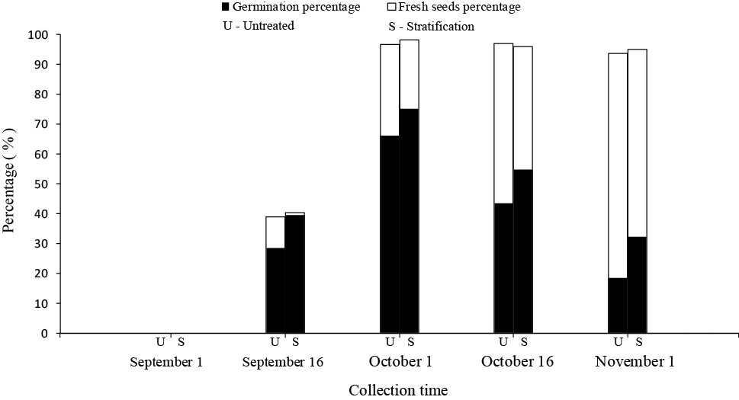

Note: U represents the unstratified seeds; and S stands for seeds treated with cold stratification for 30 days; S stnification for 30 days, respecteeds were thanot germination bresh.

Fig. 2.
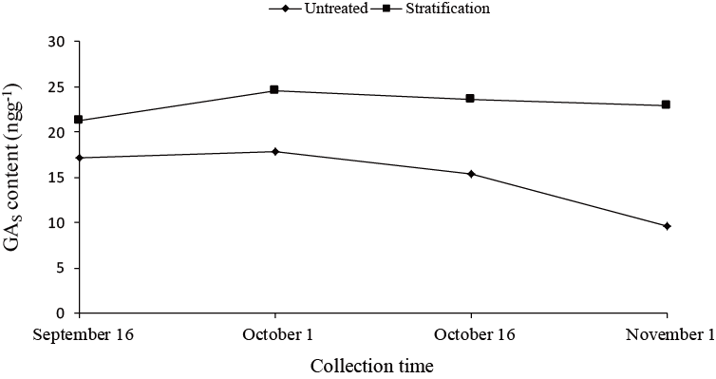

Note: The curve labeled with “Untreated” corresponds to seeds without cold stratification; The curve labeled with “Stratification” stands for seeds treated with cold stratification for 30 days.cold stratific for
Fig. 3.
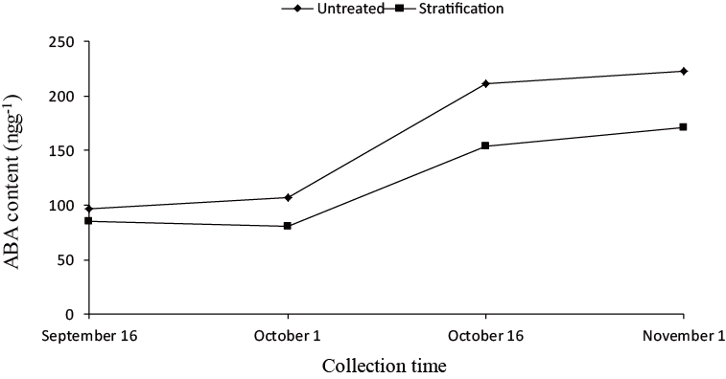

Note: The curve labeled with “Untreated” corresponds to seeds without cold stratification; The curve labeled with “Stratification” stands for seeds treated with cold stratification for 30 days..
stratification for 30 days.
Fig. 4.
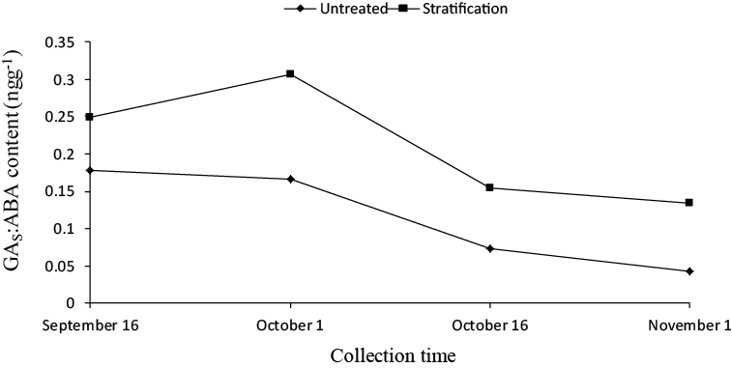

Note: The curve labeled with “Untreated” corresponds to seeds without cold stratification; The curve labeled with “Stratification” stands for seeds treated with cold stratification for 30 days..
stratification for 30 days.

